**Sprint 1 Plan**

*Product:* $h0pLyf3

*Team:* Fantastic Five

*Sprint Completion Date:* Sunday, November 5th, 2017

*Revision:* 1.0

*Revision Date:* October 26th, 2017

*Goal:* We hope to learn the technologies we will be working with, deploy a server, build a basic front end, add some test accounts with dummy data (to make sure logging in, out, and displaying works), and allow the creation of new user accounts.

*Task listing:*

**User Story 1:** As a shopper, I want to be able to login to my account.

* Set up a server (10)
* Create front end to display login page (9)
* Make the login process smooth and look nice (using CSS) (20)

**User Story 2:** As a developer, I want a database set up.

* Set up database (3)
* Add test data to system (3)
* Build back end to access database (3)

**User Story 3:** As a developer, I want to learn Django.

* Download required frameworks (0/free)

*Team Roles:*

**Connor Thurmond**: Product Owner, Developer

**Anna Lin:** Scrum Master, Developer

**Andrew Gilchrist:** Developer

**Michael Tang:** Developer

**Nikolai Chen:** Developer

*Initial task assignment:*

**Connor Thurmond**: As a shopper, I want to be able to login to my account and access my recipes and ingredients, Download and learn required frameworks well enough to set up a database.

**Anna Lin:** As a shopper, I want to be able to login to my account and access my recipes and ingredients, Download and learn required frameworks well enough to set up a database.

**Andrew Gilchrist:** As a shopper, I want to be able to login to my account and access my recipes and ingredients, Download and learn required frameworks well enough to set up a database.

**Michael Tang:** As a shopper, I want to be able to login to my account and access my recipes and ingredients, Download and learn required frameworks well enough to set up a database.

**Nikolai Chen:** As a shopper, I want to be able to login to my account and access my recipes and ingredients, Download and learn required frameworks well enough to set up a database.

*Initial burnup chart:*

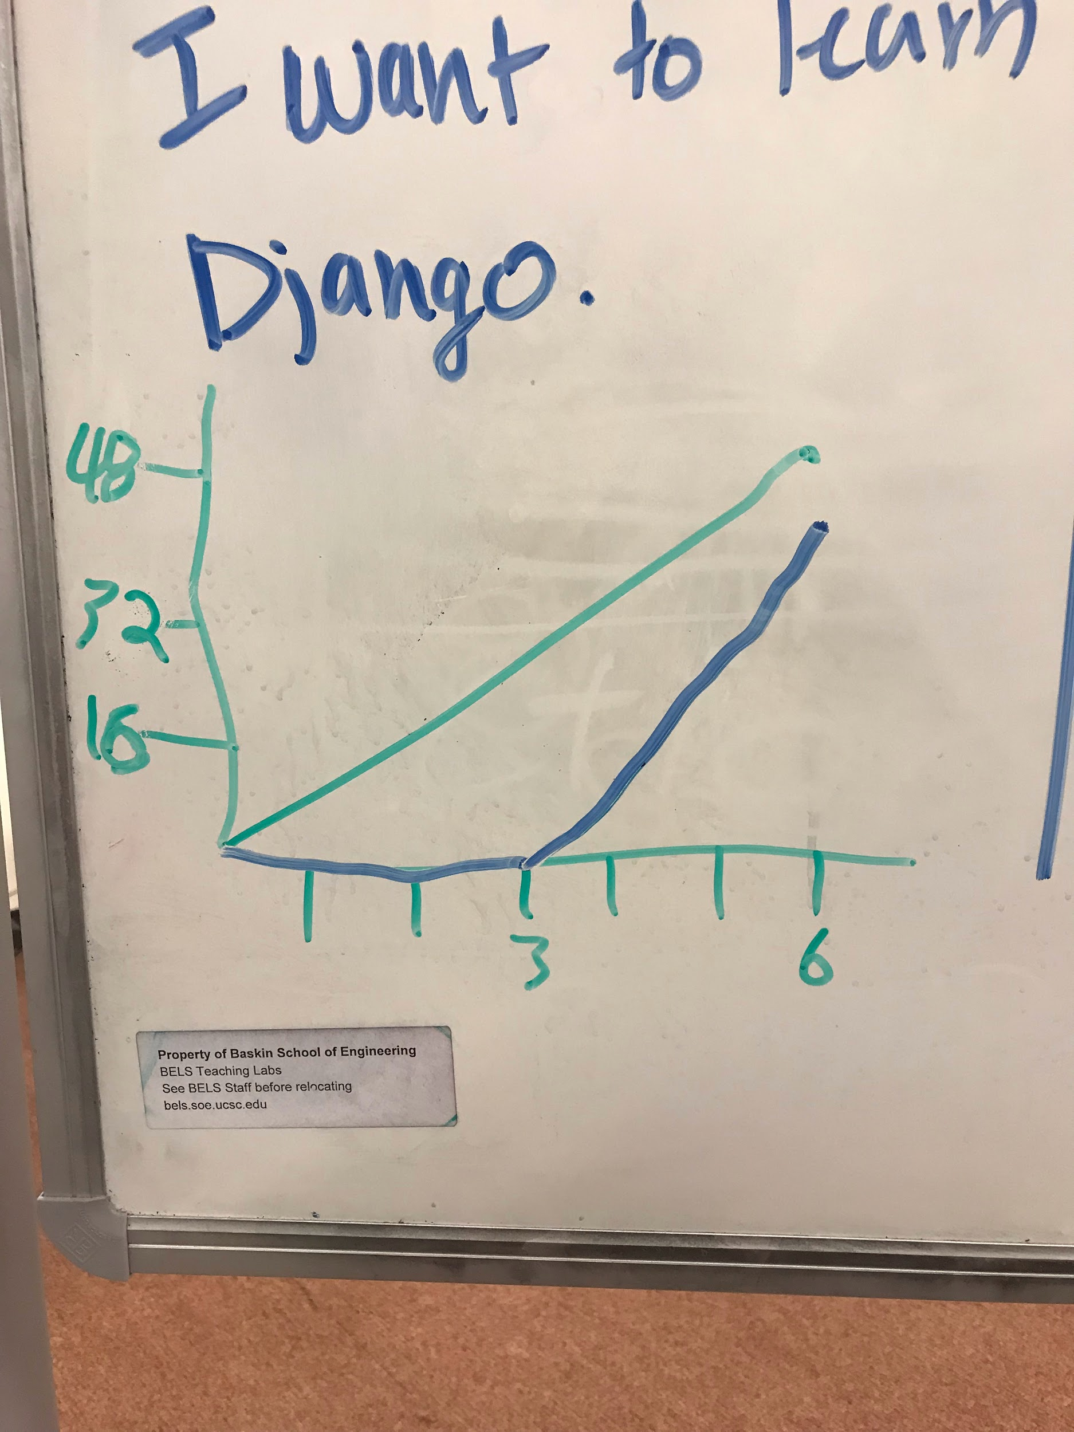

*Initial scrum board:*

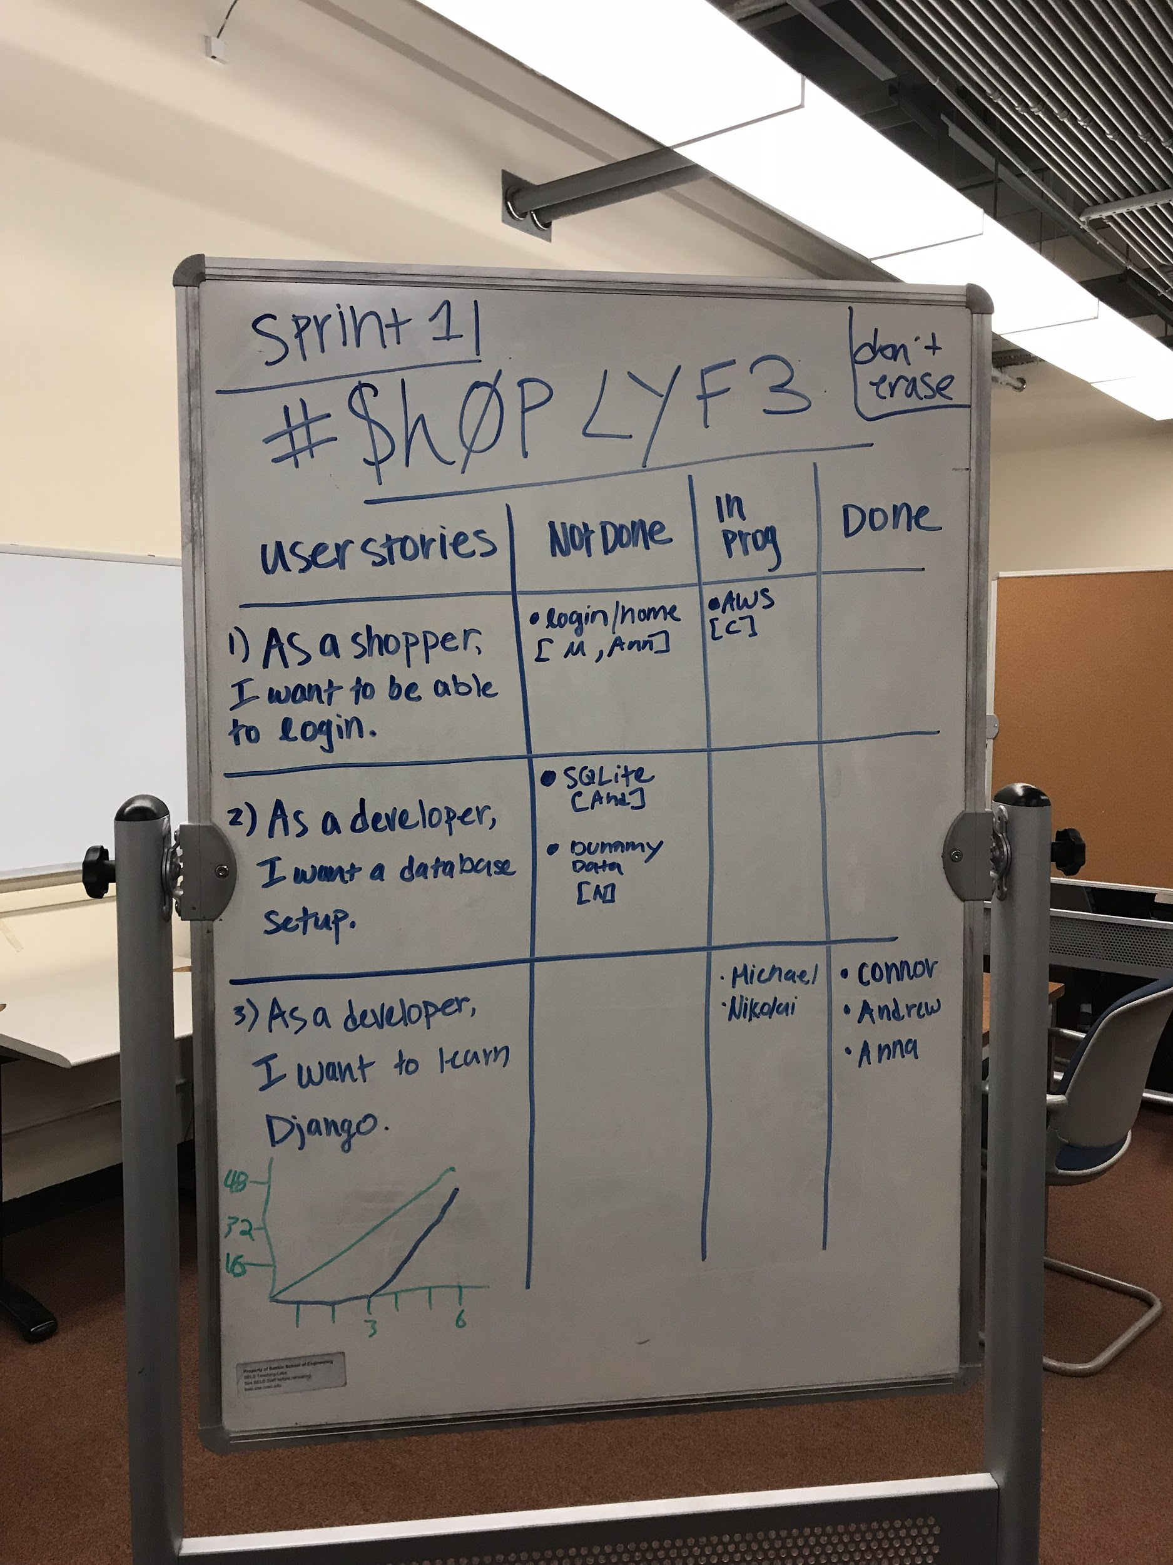

*Scrum times:* Our team will meet Monday and Wednesday from 10:30-12:00. We will meet with a TA on Thursday from 5:20 - 5:40.